**LITERATURE SURVEY**

A Literature review surveys books,scholarly articles,andany othersourcesrelevant to particular issue,area of research,or theory,and by so doing, provides a description,summary,and critical evaluation of these works in relation to the research problem being investigated.

**PROBLEM IDENTIFICATION**

In existing, we need to maintain the excel sheets, csv etc. files for the user daily and monthly expenses. In existing, there is no as such complete solution to keep a track of its daily expenditure easily. to do so a person as to keep a log in a diary or in a computer, also all the calculations needs to be done by the user which may sometimes results in errors leading to losses. This project is about mobile application Expenses system with geo-location tracking,Based on the location of the user, it using Google Places, to check, the available store in the area, provides a notification for offers purpose, In term of security design, this system may implement a login authentication such as OTP message to your mobile device, this function may bring more security confidence to user.

**PROBLEM SOLUTION**

The system known as Budget Estimator is designed to manage the application user‘s daily expenses in a more efficient and manageable way.By using this application we can reduce the manual calculations for their daily expenses and keep the track of the expenditure. This project is about mobile application Expenses system with geo-location tracking, Based on the location of the user, it using Google Places, to check, the available store in the area, provides a notification for offers purpose, In term of security design, this system may implement a login authentication such as OTP message to your mobile device, this function may bring more security confidence to user. To reduce manual calculations, we propose an application which is developed by android. this application allows users to maintain a digital automated diary. each user will be required to register on the system at registration time, the user will be provided id, which will be used to maintain the record of each unique user. expense tracker application which will keep a track of income-expense of a user on a day to day basis. this application takes income from user and divides in daily expense allowed. if u exceed that days expense it will cut if from your income and give new daily expense allowed amount, and if that days expense is less it will add it in savings. expense tracking application will generate report at the end of month to show income-expense via multiple graphs. it will let you add the savings amount which you had saved for some particular festivals or day like birthday or anniversary.

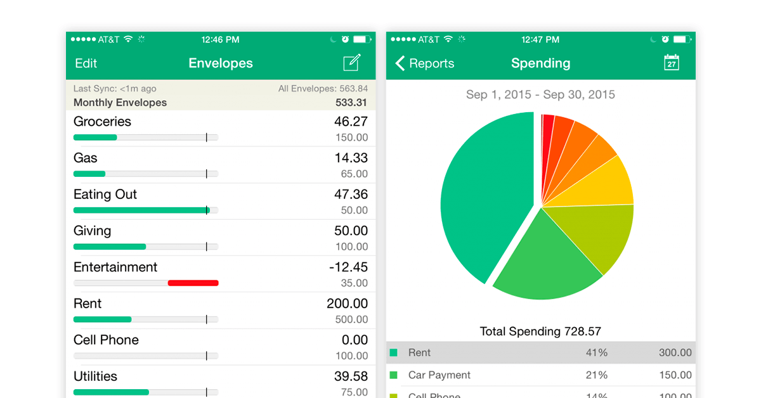

**REFERENCES**

* International Research Journal of Engineering and Technology (IRJET).
* https://www.researchgate.net/publication/237448489_Intelligent_Online_Budget_Tracker (Bekaroo, Girish & Sunhaloo, Sameer. (2007). Intelligent Online Budget Tracker.)

**CONCLUSION**

Tracking your expenses daily can not only save your amount, but it can also assist you set financial goals for the longer term. If you know exactly where your amount goes every month, you will easily see where some cutbacks and compromises can be made. The project that we have developed is more efficient than the other income and expense trackers. The project successfully avoids the manual calculation which is performed usually in the absence of an expense tracker. The modules are developed efficiently and also in an attractive manner. The application will eliminate sticky notes, spreadsheets, and ledgers that cause confusion, data inconsistency problems while recording and splitting expenses. With our application users can manage their expenses more effectively and they will be better at managing the expenses.